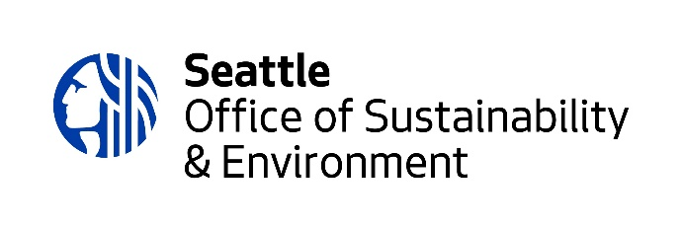
Environmental Justice Fund

2023 Environmental Justice Fund Application
Mid-size Project Worksheet

This worksheet is provided to applicants for drafting purposes only. You may use this worksheet only if you will submit a proposal for funding ranging from $10,000-$40,000. Final application responses must be submitted through the Survey Monkey portal here.

Please review the 2023 EJF Guidelines, as they provide useful information about the application process. Refer to page 8 for the criteria the Review Team will use to review proposals.

Application Attachments
Your application will need to include the following attachments:

☐Project budget
☐Landowner agreement, if applicable

Proposal Eligibility:

We recognize drafting a proposal requires time and resources. Before you submit a proposal, this section will walk you through the EJ Fund eligibility requirements to help you determine if you should submit a proposal.

- Does your project directly address environmental and/or climate inequities in the City of Seattle?

  - Yes [continue]
  - No [end survey]

- Does your project primarily benefit those who live, work, worship and play in the City of Seattle?

  - Yes [continue]
  - No [end survey]

- Does your project or program occur within Seattle city limits?

  - Yes [continue]
  - No [continue]

- Is your project led by or in partnership with those most affected by environmental and climate inequities?
  - Yes [continue]
  - No [end survey]

- Is your group a 501c3 nonprofit organization? Yes/No
  - Yes [continue]
  - No [follow up question]:
    - Is your group willing to get a 501c3 fiscal sponsor if awarded EJ Fund funding?
      - Yes [continue]
      - No [end survey]

- Do you currently have an EJ Fund grant that is less than 75% complete?
  - No [continue]
  - Yes [end survey; please reach out to EJ Fund Program Manager, Ximena Fonseca Morales at ximena.fonseca-morales@seattle.gov to discuss your proposal idea.]

Application Questions

General Information

1. Your organization's/group's name, address, webpage (optional), and phone number

2. Your organization's/group's leader name, title, email, and phone number

3. Your project leader’s name, title, email, and phone number (if diﬀerent from the organization/group leader)

4. Tell us how many paid staﬀ you have, if any.

Full time:
Part time:

5. How many volunteers would support your proposed project, if any?

6. Provide a short description (3-4 sentences) about your project and the community(ies) served.

*7. What kinds of eligible activities does your project involve?

Select up to three that apply from the list below.
- Primary (required):
- Additional (optional):
- Additional (optional):

- Arts and storytelling  - Capacity building* for the organization, group, and/or community  - Climate change adaptation  - Climate change resilience  - Climate or environmental justice education  - Climate or environmental justice engagement, and/or outreach  - Coalition building to advance climate or environmental justice  - Community health | - Community organizing  - Cultural knowledge preservation and/or education  - General operating support  - Neighborhood and community planning or visioning, including the design phase  - Organizational strategic planning or visioning  - Skills building and development for green jobs pathways

*8. What geographic communities does your project serve? Select all that apply.
- Beacon Hill
- Bitter Lake
- Central Area
- Chinatown-International District
- Delridge
- Georgetown
- Haller Lake
- Lake City
- Mount Baker
- Othello
- Rainier Beach
- South Park
- Other (please specify)

Project Information

Refer to page 8 of the 2023 Environmental Justice Fund Guidelines for the criteria the Review Team will use to review proposals.

Response length: We encourage brief responses whenever possible (1-3 paragraphs), keeping in mind the capacity of the community reviewers. If reviewers want more details or clarification, they can ask for them during the Q&A period.

9. What is the size of the grant are you seeking?
a. $10,001-40,000
b. $40,001-90,000

Narrative Questions for Mid-Size Project Fund:

*10. COMMUNITY NEED: Who is the community you are serving? How is your community being impacted by climate change and/or environmental hazards?

*11. PROJECT DESCRIPTION: What will you do, and how will you do it?

*12. COMMUNITY LEADERSHIP: Who designed the project? If different, who is leading the project and what lived experiences/skills do they bring?

*13. MILESTONES: Provide a list of the main activities (milestones) that will be completed through this project.

*14. IMPACT: What are your project outcomes? How do these outcomes address the community impacts you named in “Community Need”?

*15. RACIAL JUSTICE: What practices and approaches does your organization or group use to advance racial justice? How do you measure the success of your practices and approaches?

*16. Please upload your project budget. You may upload as a PDF. Download template here.

17. If your project involves changes to a space or takes place on property that is not owned by your group or organization, please attach a letter of authorization from the land or property owner.

*18. Would you accept less than the requested amount and modify your proposal accordingly?

Yes
No

*20. What is the minimum grant amount you would need?

21. For projects related to land/property acquisition, capital development or infrastructure investment: While the Environmental Justice Fund is unable to fund these types of projects, we would like to help connect you with other funding opportunities that do, such as Seattle Office of Planning & Community Development’s Equitable Development Initiative (EDI). Do you want to be connected to them? (Answer to this question does not impact the status of your grant application.)
- Yes
- Not at this time

END.

